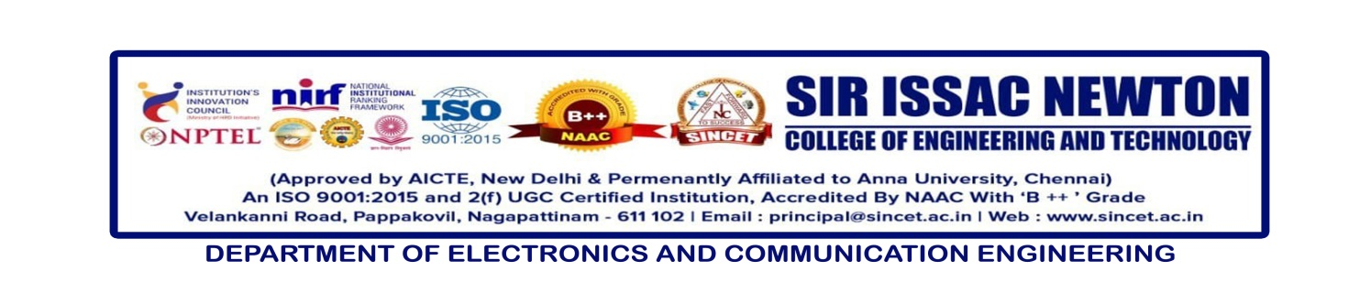**Date** **: 04-03-2025**

**Seminar Title** **: Advanced Transistor Technology in Nanoelectronics for VLSI**

**Resource Person : Dr. Padmanaban, Asso.Prof /ECE, AAA College of Engg & Tech,**

**Co-ordinator : Prof. S.Balamurugan, AP/ECE & Prof. K.Janani, AP/ECE**

**Course Objectives:**

* To introduce the fundamentals of advanced transistor technology and its applications in nanoelectronics.
* To understand the impact of scaling and miniaturization in VLSI design.
* To explore the latest trends and advancements in nanoelectronic transistors, including FinFETs, Tunnel FETs, and 2D-material-based transistors.
* To analyze the challenges and solutions related to power consumption, leakage current, and fabrication techniques in nanoelectronics.
* To provide insights into the future scope of nanoelectronics in semiconductor industries.

**Course Outcomes:**

**After completing the seminar, participants will be able to:**

* Understand the principles and working of advanced transistor technologies used in nanoelectronics.
* Analyze the impact of device scaling and how it affects performance, power, and reliability in VLSI circuits.
* Evaluate different nanoelectronic transistor architectures and their applications in modern semiconductor devices.
* Identify the challenges in low-power and high-speed transistor design and propose suitable techniques to overcome them.
* Gain exposure to emerging research trends in nanoelectronics and semiconductor technology for future developments in VLSI.

|  |  |  |  |  |  |  |  |  |  |  |  |  |  |  |
| --- | --- | --- | --- | --- | --- | --- | --- | --- | --- | --- | --- | --- | --- | --- |
| **CO** | **PO1** | **PO2** | **PO3** | **PO4** | **PO5** | **PO6** | **PO7** | **PO8** | **PO9** | **PO10** | **PO11** | **PO12** | **PSO1** | **PSO2** |
| **1** | 3 | 2 | 2 | 1 | 3 | 0 | 0 | 0 | 0 | 0 | 0 | 2 | 3 | 1 |
| **2** | 3 | 3 | 2 | 2 | 3 | 0 | 0 | 0 | 0 | 0 | 0 | 2 | 3 | 1 |
| **3** | 2 | 3 | 3 | 2 | 3 | 1 | 0 | 0 | 0 | 0 | 0 | 3 | 3 | 2 |
| **4** | 2 | 3 | 2 | 3 | 3 | 2 | 1 | 1 | 0 | 0 | 2 | 3 | 3 | 2 |
| **5** | 3 | 2 | 2 | 2 | 3 | 0 | 1 | 0 | 0 | 2 | 2 | 3 | 3 | 3 |

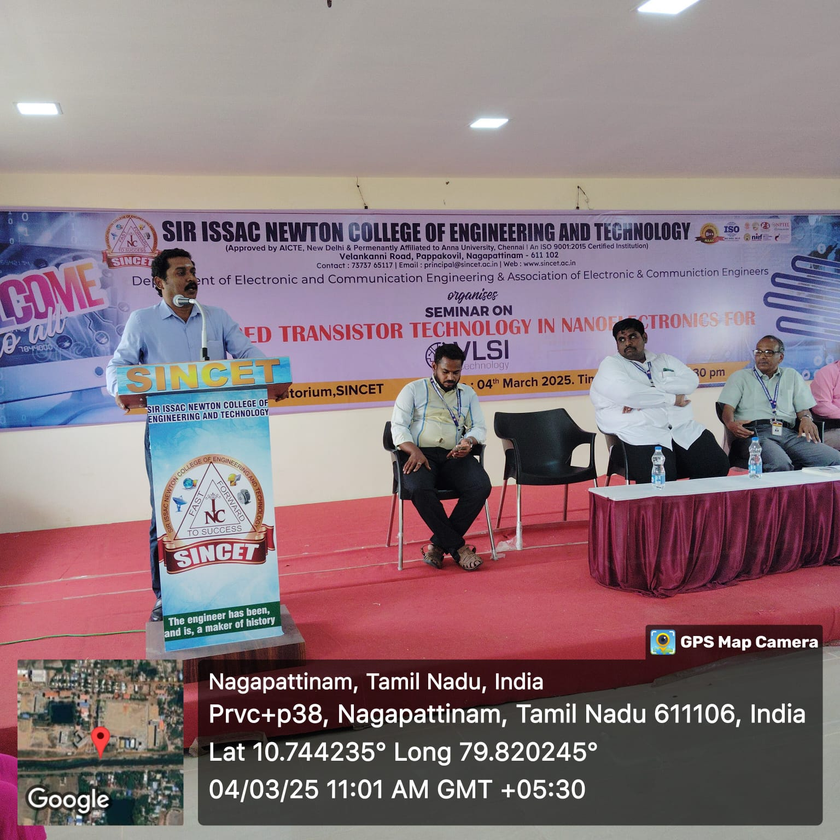

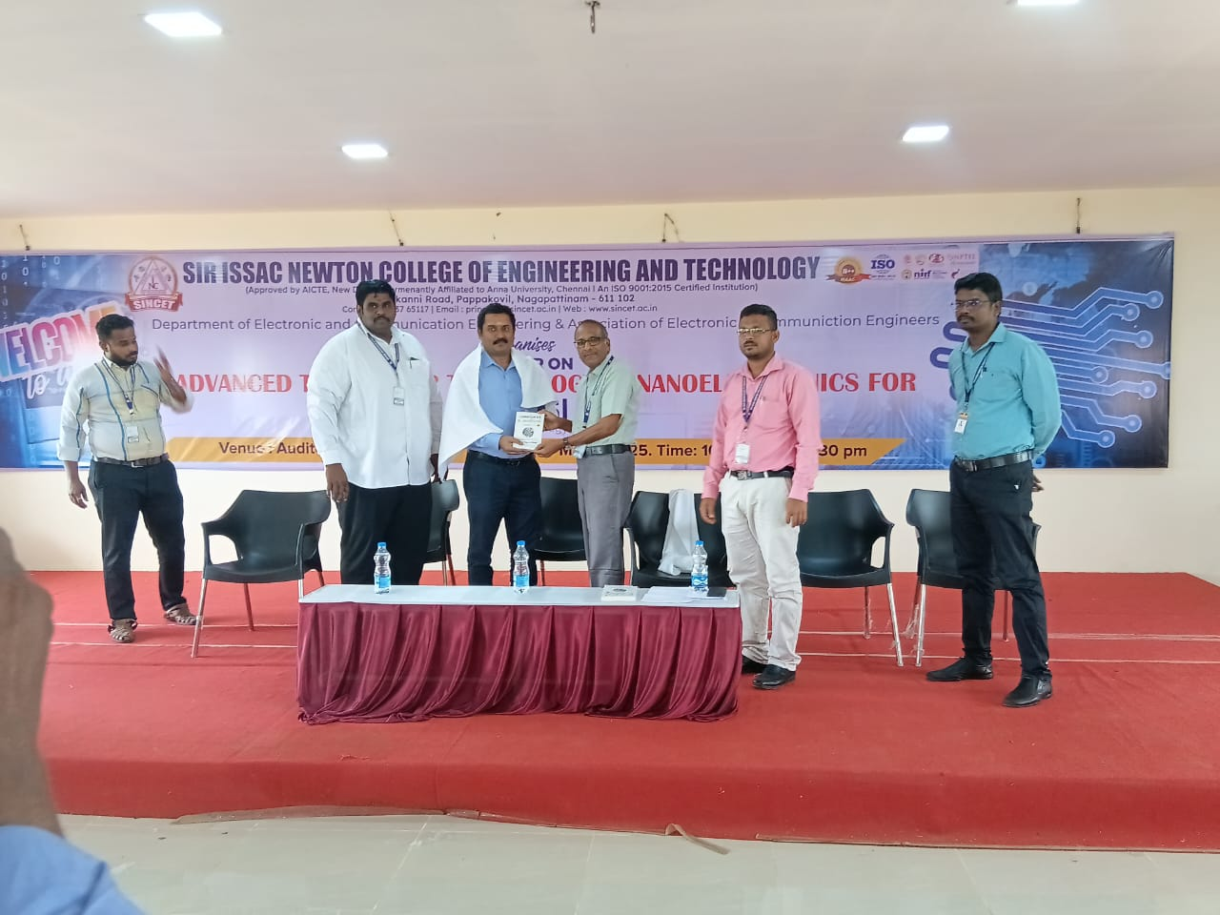

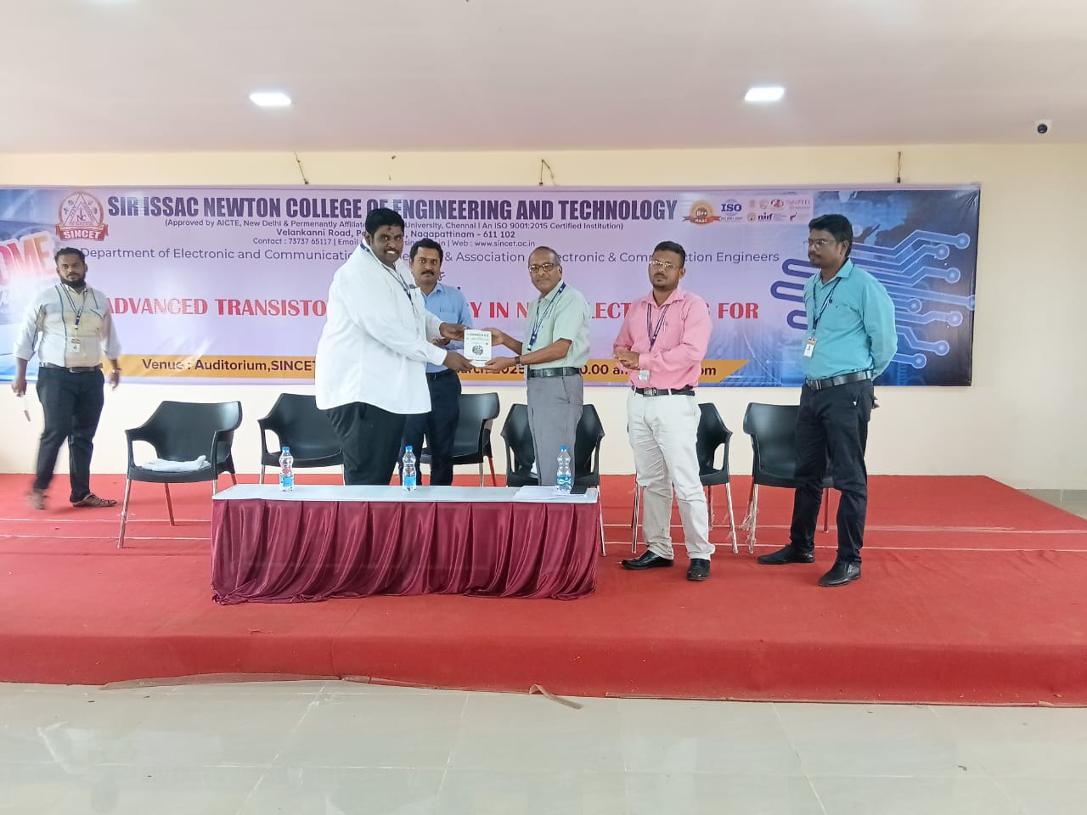

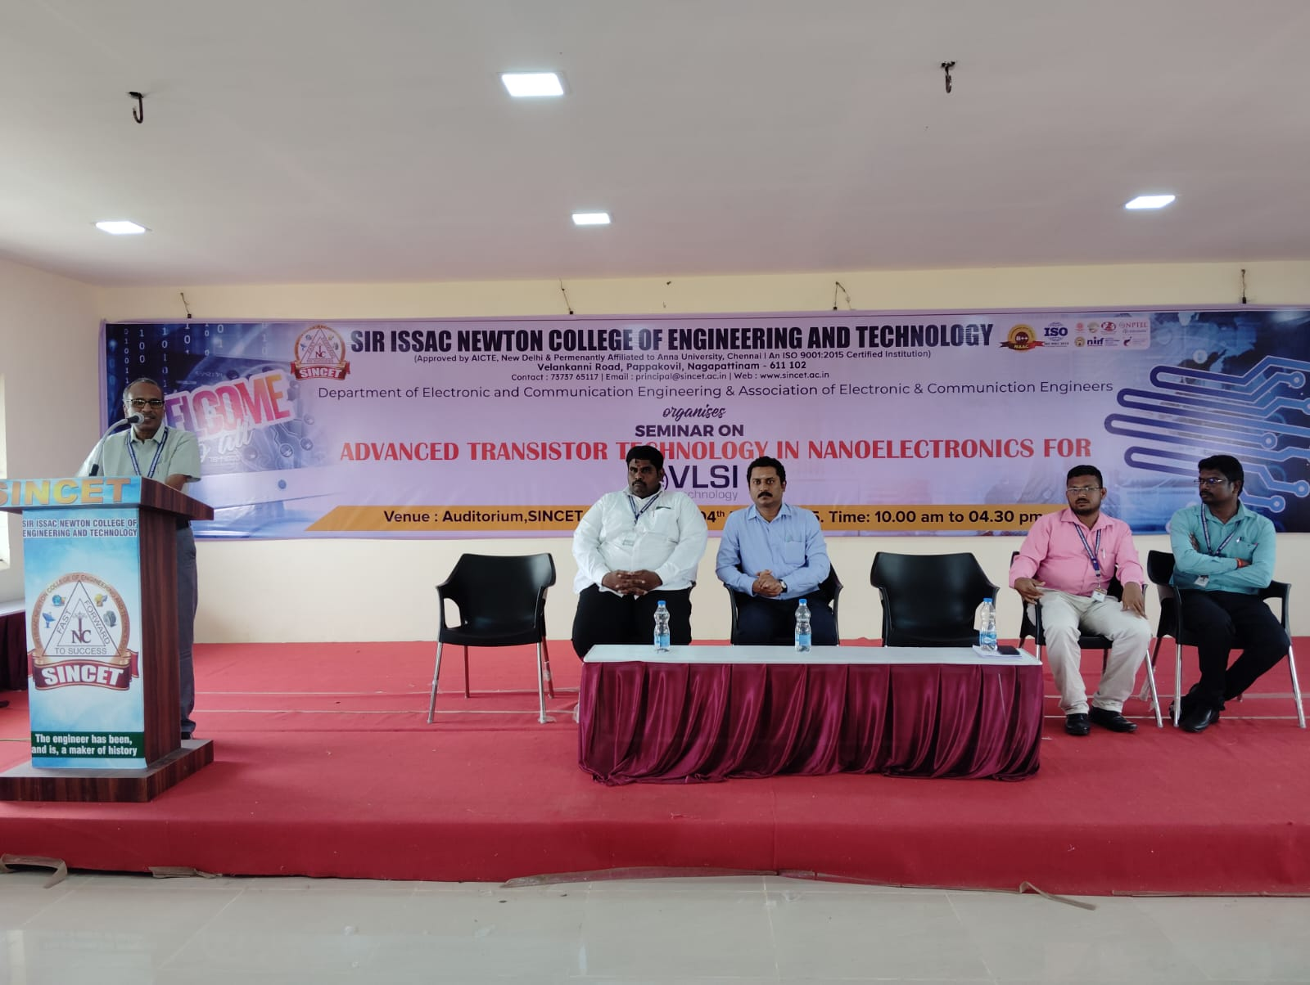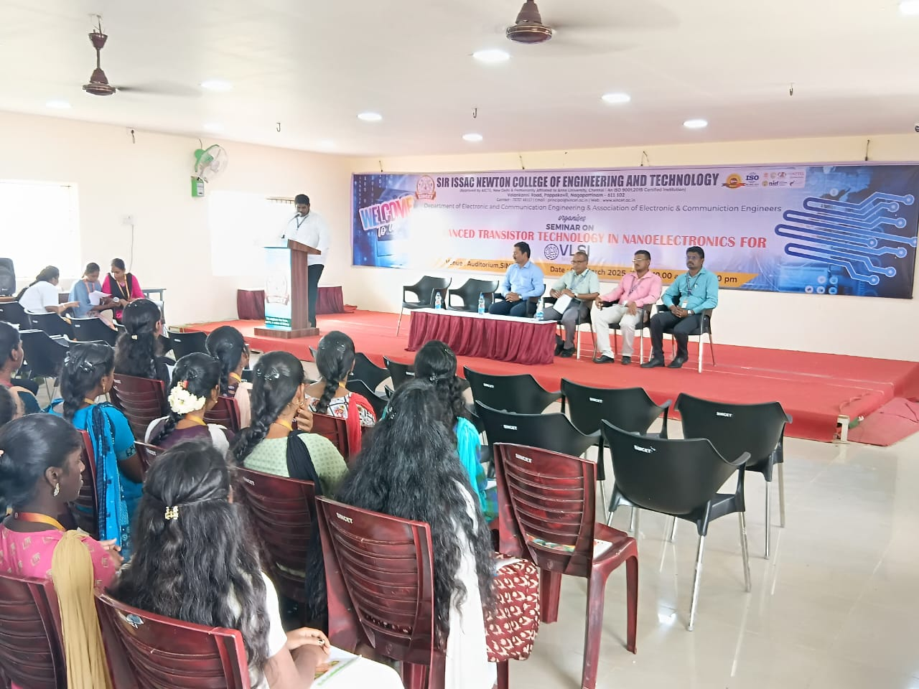

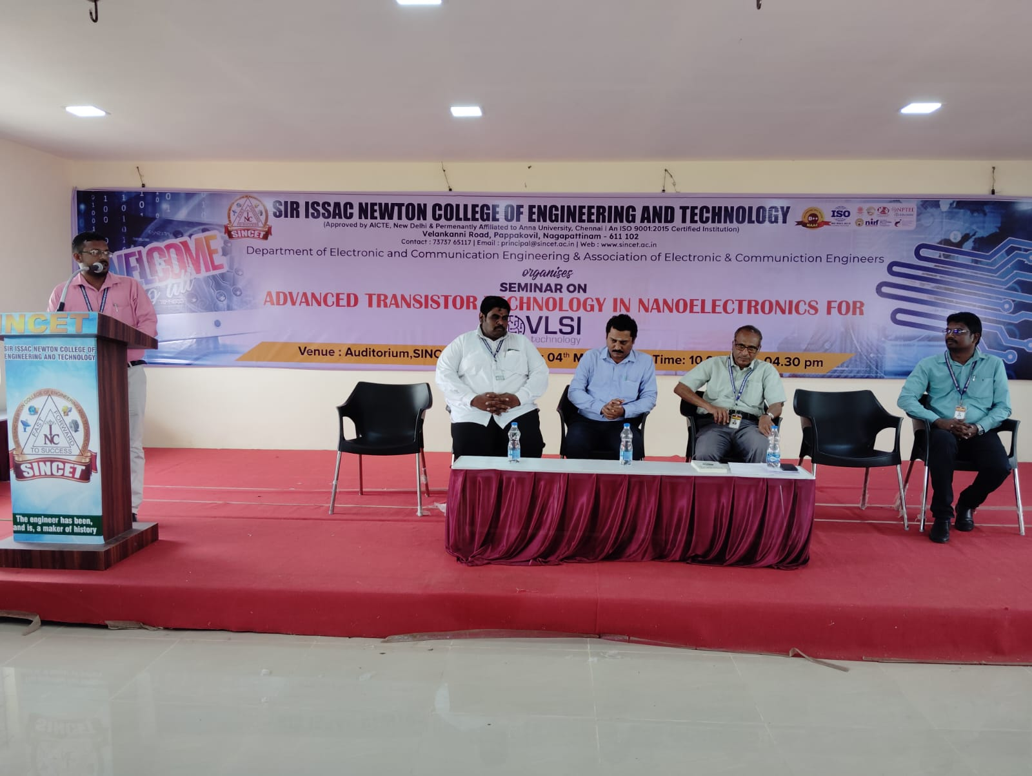

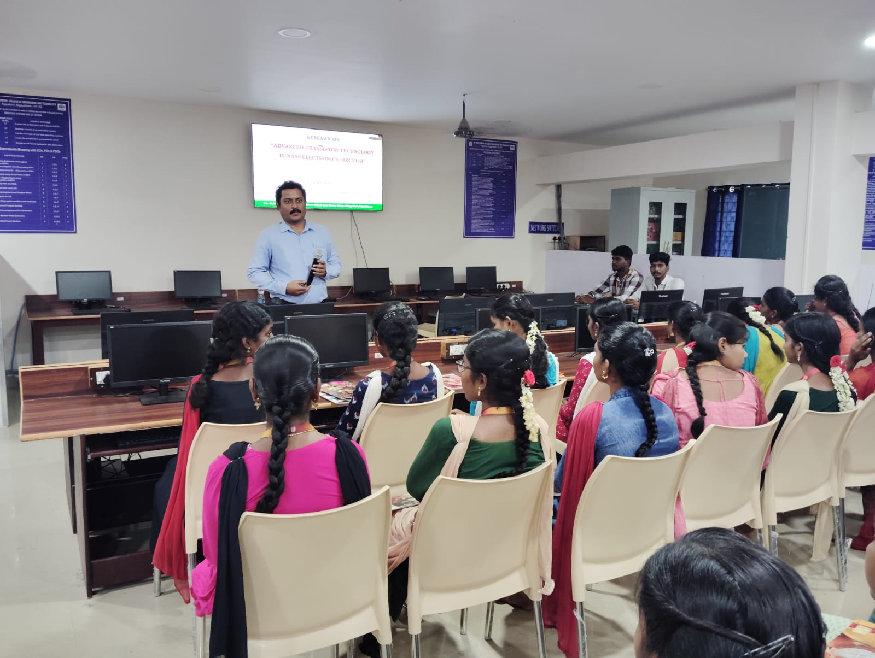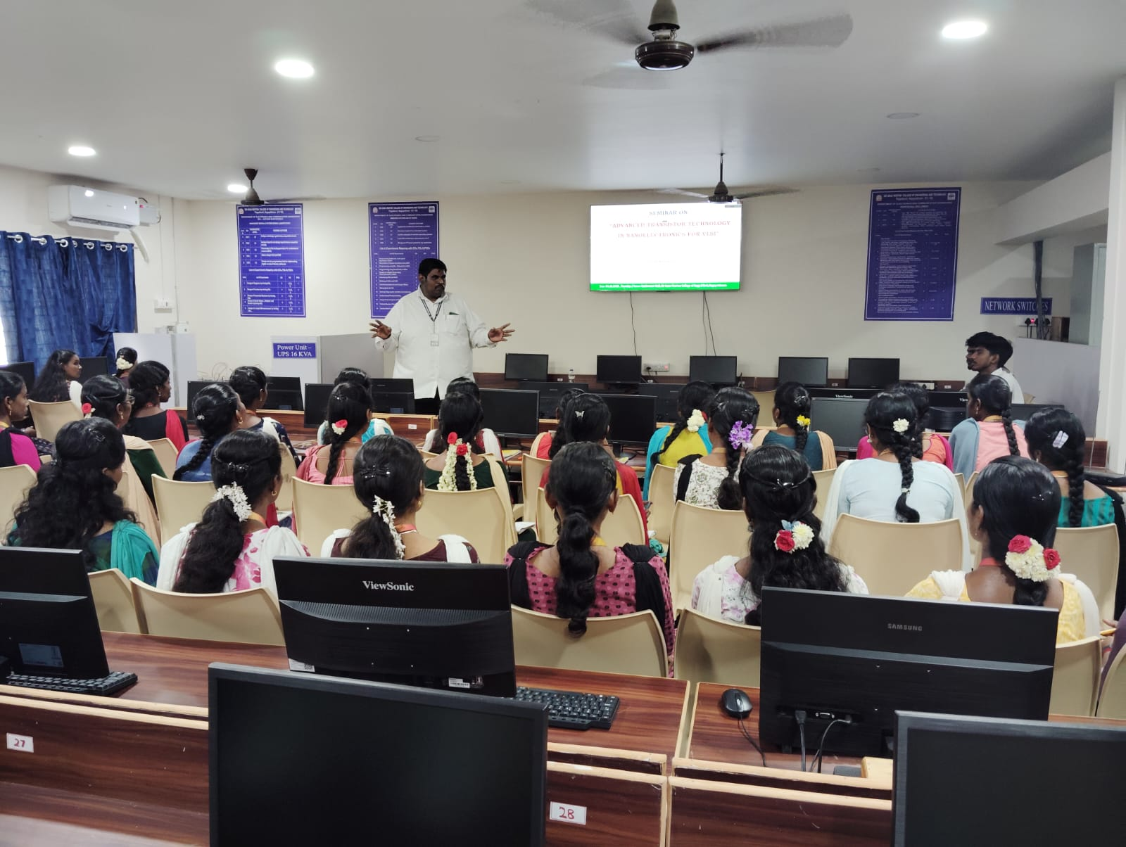

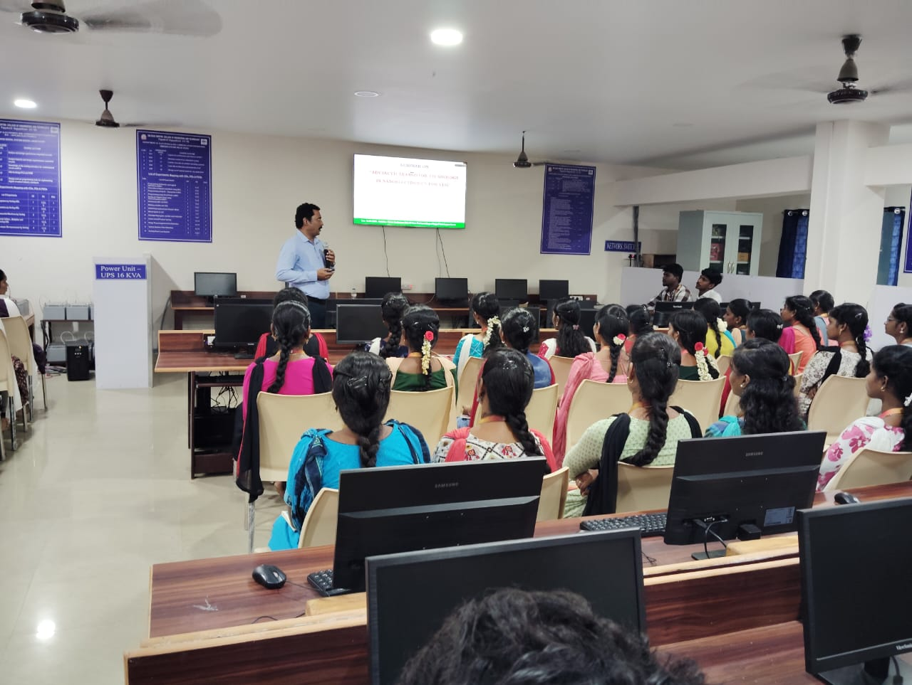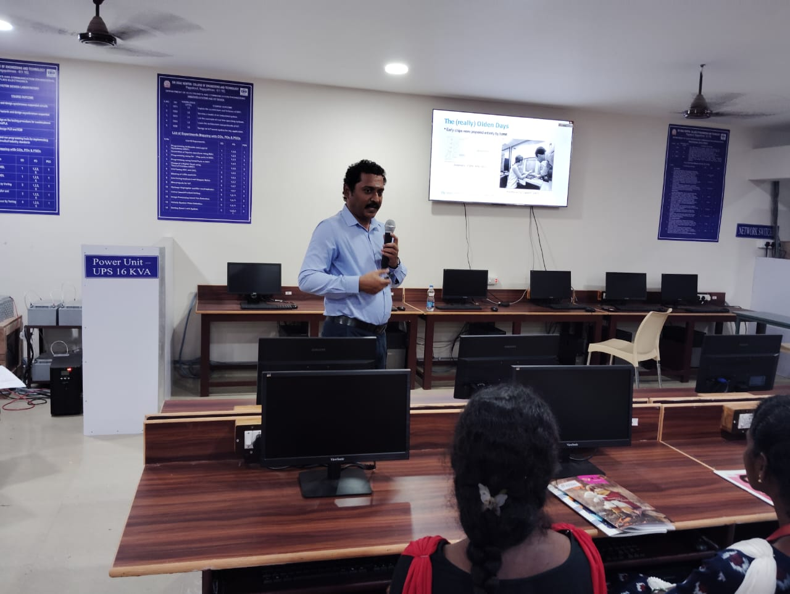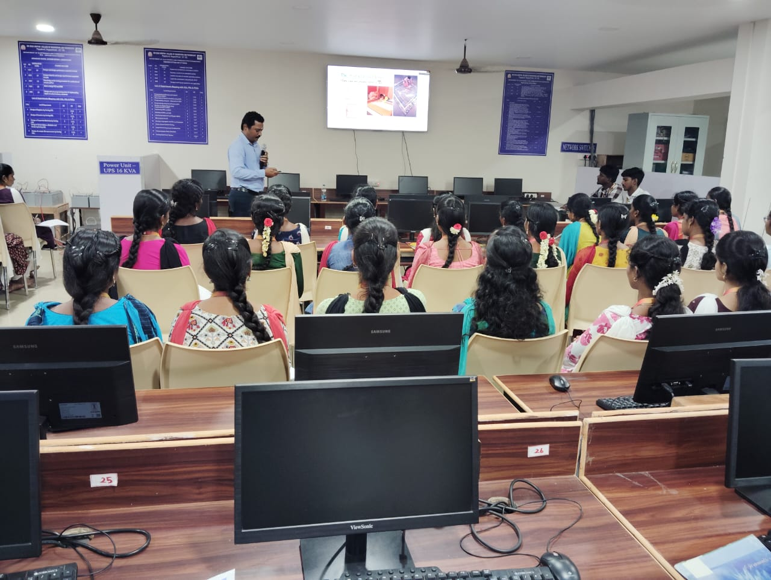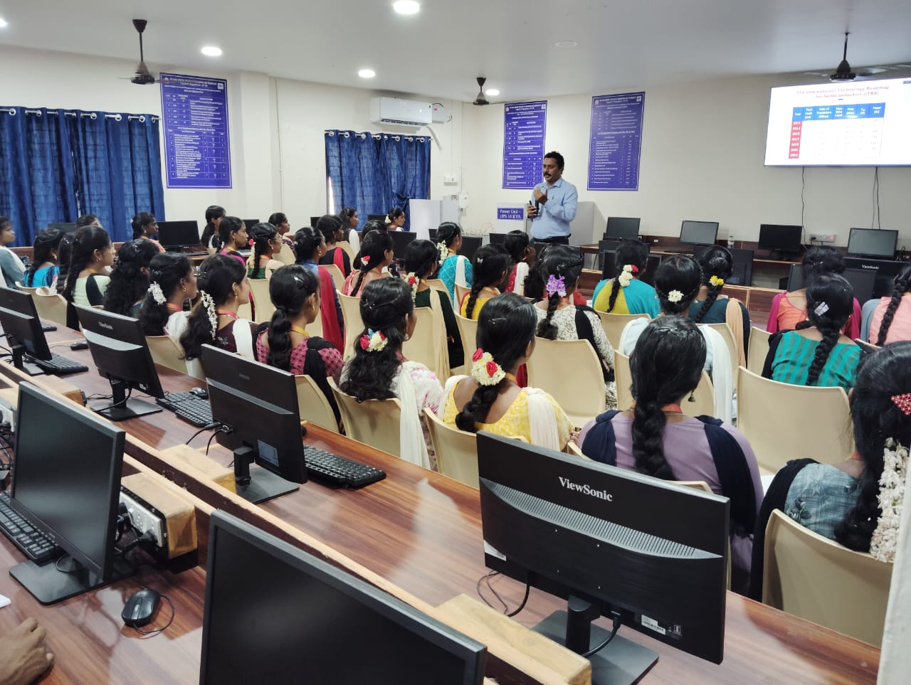

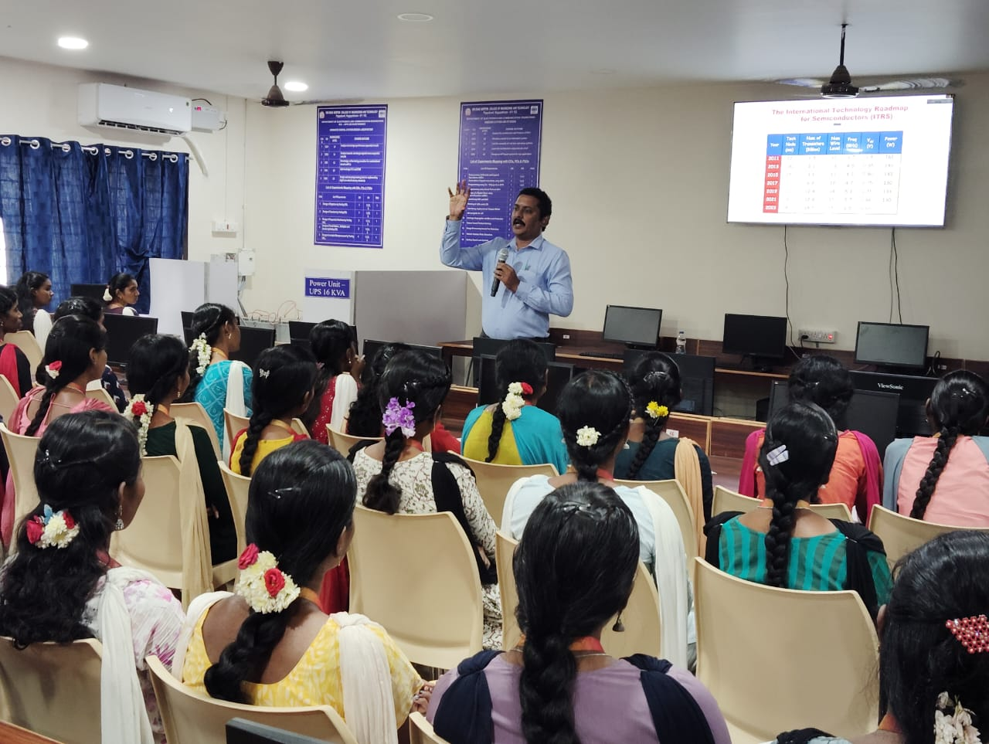

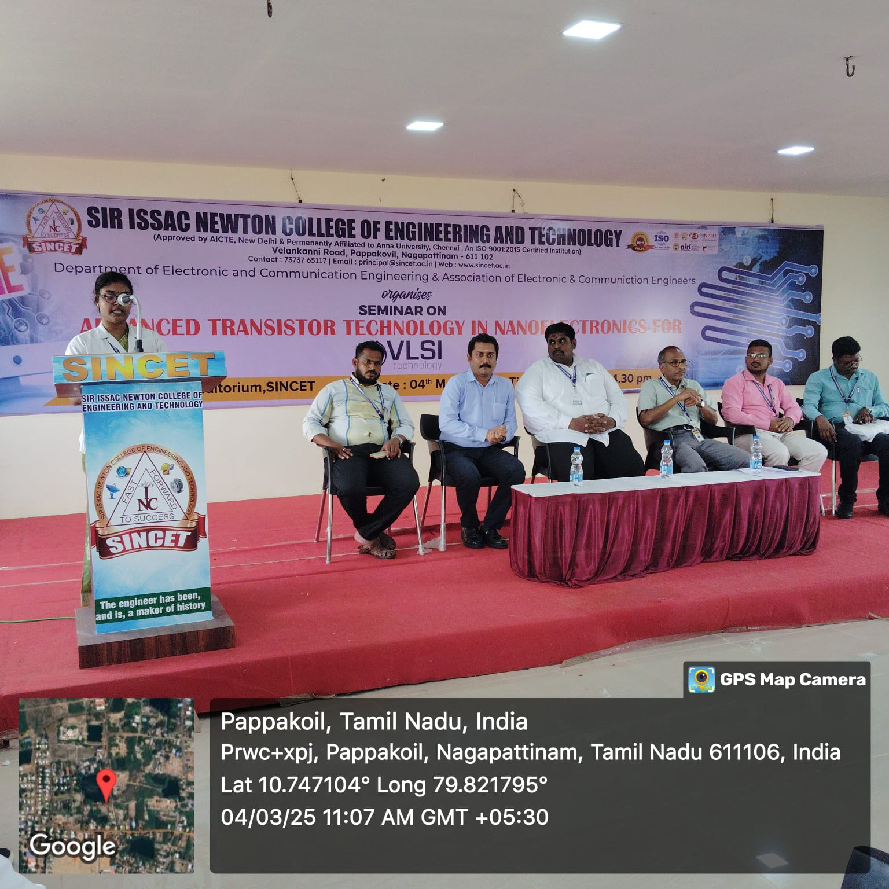

The Department of Electronics and Communication Engineering at Sir Isaac Newton College of Engineering and Technology organized a seminar on **"Advanced Transistor Technology in Nanoelectronics for VLSI"** on March 4, 2025. A total of **92** students participated in the event.

The seminar commenced at morning with the inaugural session. Mrs. Aarthi delivered the welcome address, followed by an introductory speech and resource person introduction by Mr. P. Navaneethakrishnan, HoD/ECE.

The chief guest address was delivered by Dr. A. Kumaravadivel, Principal, while the presidential address was given by Dr. K. Elangovan, Academic Coordinator, highlighting the significance of electronics in modern life and the role of "**Make in Electronics**" initiatives.

The resource person for the seminar was Dr. Padmanaban, Associate Professor, AAA College of Engineering and Technology, Sivakasi, who delivered a session on "Recent Technology in Nano Electronics."

The vote of thanks was proposed by Ms. K. Janani, expressing gratitude to all dignitaries and participants.

The Technical session, led by the resource person, took place from one day, covering various aspects of “**Advanced Transistor Technology in Nano Electronics for VLSI”**.